A PBL Project Report

Database Management System

(UCS4001, <2cse6>)
<UNIVERSITY COURSE REGISTRATION>

Submitted in partial fulfilment of the requirements for the award of the degree of
BACHELOR OF TECHNOLOGY


SCHOOL OF COMPUTER SCIENCE AND ENGINEERING IILM UNIVERSITY,
GREATER NOIDA, INDIA 2025-26
in April, 2026
By
ANANT RAJ(2410031035)
SHUBH MASURAHA(2410031065)
AADARSH RAJ(2410031053)

Under the guidance of - Dr. Ashish Kumar Rastogi

Table of Contents
1. Introduction
2. Objectives
3. System Requirements
4. Literature Review
5. Database Design
6. Normalization
7. ER Diagram
8. SQL Queries

Introduction
The University Course Registration System is developed to manage academic data efficiently using a relational database.
It handles student registration, course allocation, professor assignment, and enrollment tracking.
The system reduces redundancy and ensures data consistency.

Objectives
• To manage student information efficiently.
• To maintain course and professor records.
• To handle student enrollment properly.
• To enforce relational integrity using constraints.
• To eliminate redundancy using normalization.

System Requirements
Hardware Requirements:
• Computer with minimum 4GB RAM
• 10GB free storage
Software Requirements:
• MySQL / SQL Server
• XAMPP (optional)
• MS Word
• Windows 10 or above

Literature Review
Database Management Systems are widely used in educational institutions to automate processes.
Relational databases use tables with primary and foreign keys to maintain structured data.
ER diagrams help in designing database structure before implementation.

Database Design
The database consists of five tables:
1. Department
2. Professor
3. Student
4. Course
5. Enrollment
Each table contains primary keys and foreign keys to maintain relationships.

Normalization
First Normal Form (1NF): Ensures atomic values.
Second Normal Form (2NF): Removes partial dependency.
Third Normal Form (3NF): Removes transitive dependency.
The database is normalized up to 3NF to reduce redundancy.
PHASE 1 : Make ER Diagram, and Database of university course registration.

ER Diagram
The ER diagram below shows all entities, attributes, and relationships with cardinalities.
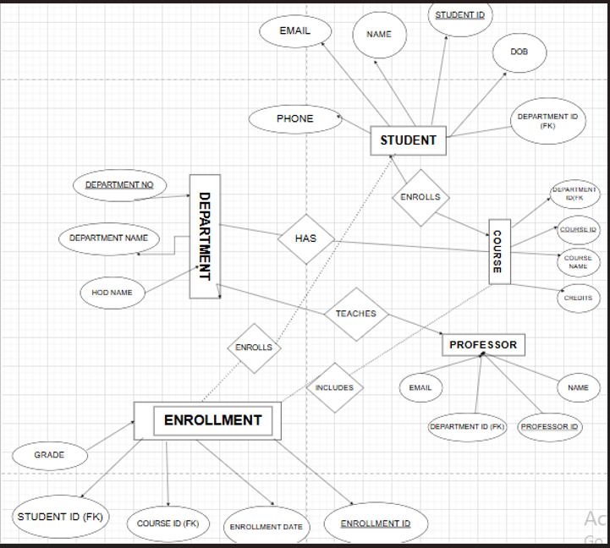
Parents name

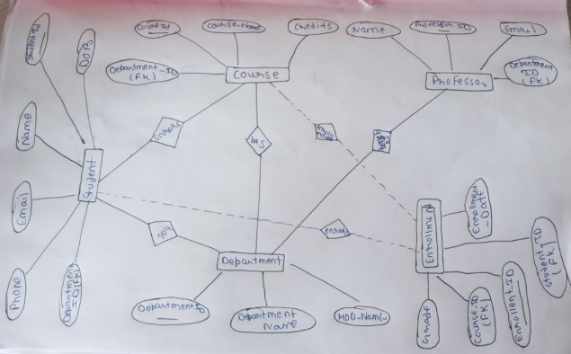
SQL QUERIES
- FIRST WE CREATE A DATABASE OF UNIVERSITY COURSE REGISTRATION WITH NAME - university_registration .
- CREATE DATABASE university_registration;
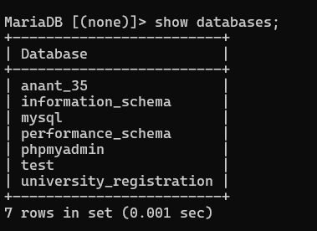
- After it select the database university_registration and create tables inside the database of course , department , enrollment, professor , student .

- CREATE TABLE Department ( department_id INT PRIMARY KEY AUTO_INCREMENT,department_name VARCHAR(100) NOT NULL, hod_name VARCHAR(100));
For justify how department table create then use Desc department;
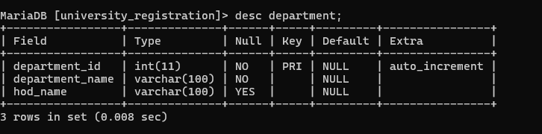
- CREATE TABLE Student ( student_id INT PRIMARY KEY AUTO_INCREMENT, name VARCHAR(100) NOT NULL,email VARCHAR(100) UNIQUE, phone VARCHAR(15),dob DATE,parents_name VARCHAR(100),department_id INT(11));
For justify how student table create then use Desc student;
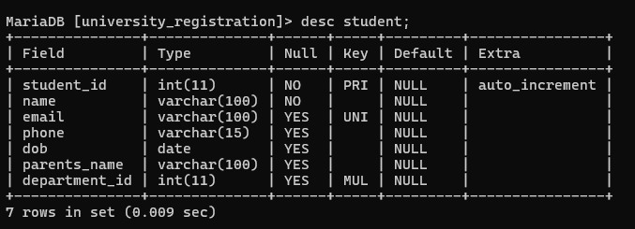

- CREATE TABLE Professor (professor_id INT PRIMARY KEY AUTO_INCREMENT, name VARCHAR(100) NOT NULL, email VARCHAR(100) UNIQUE, department_id INT, FOREIGN KEY (department_id) REFERENCES Department(department_id) ON DELETE SET NULL ON UPDATE CASCADE);

For justify how professor table create then use Desc professor;
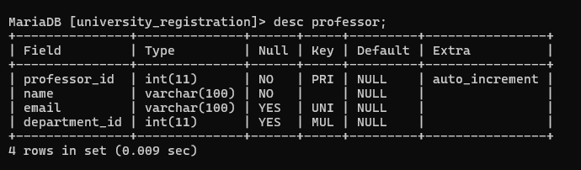
- CREATE TABLE Course (course_id INT PRIMARY KEY AUTO_INCREMENT, course_name VARCHAR(100) NOT NULL, credits INT, department_id INT, professor_id INT, FOREIGN KEY (department_id) REFERENCES Department(department_id) ON DELETE CASCADE ON UPDATE CASCADE, FOREIGN KEY (professor_id) REFERENCES Professor(professor_id) ON DELETE SET NULL ON UPDATE CASCADE);
For justify how course table create then use Desc course;
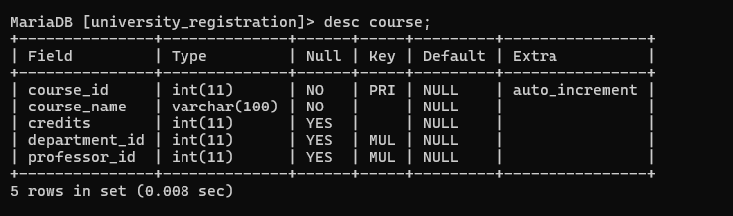

- CREATE TABLE Enrollment (enrollment_id INT PRIMARY KEY AUTO_INCREMENT, student_id INT, course_id INT, enrollment_date DATE, grade VARCHAR(5), FOREIGN KEY (student_id) REFERENCES Student(student_id) ON DELETE CASCADE ON UPDATE CASCADE, FOREIGN KEY (course_id) REFERENCES Course(course_id) ON DELETE CASCADE ON UPDATE CASCADE);

For justify how enrollment table create then use Desc enrollment;
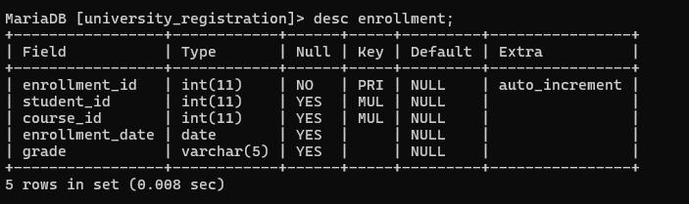

- Then we write show tables;
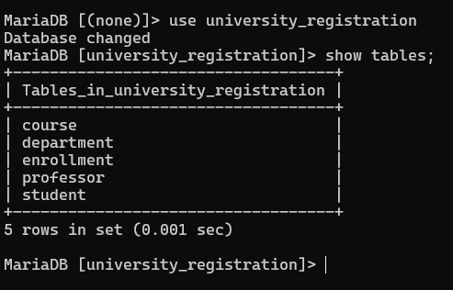

PHASE 2 : INSERT ALL VALUES IN ALL TABLES AND WRITE 10 SQL AND RELATIONAL QUERIES
FIRST WE CAN INSERT ALL THE VALUES INSIDE THE TABLE :

INSERT INTO department (department_name, hod_name) VALUES ('Computer Science', 'Dr. Rajesh Sharma') , ('Information Technology', 'Dr. Neha Verma') , ('Mechanical Engineering', 'Dr. Amit Kumar') , ('Civil Engineering', 'Dr. Suresh Singh') , ('Electrical Engineering', 'Dr. Pooja Mehta') , ('Electronics Engineering', 'Dr. Anil Gupta') , ('Mathematics', 'Dr. Kavita Joshi') , ('Physics', 'Dr. Rakesh Pandey') , ('Chemistry', 'Dr. Sunita Rao') , ('Management', 'Dr. Vivek Malhotra');

QUERY:
SELECT * FROM DEPARTMENT;
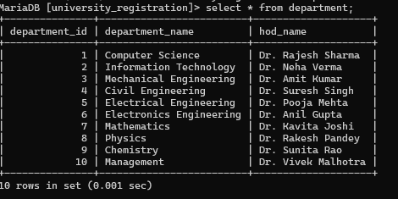
INSERT INTO professor (name, email, department_id) VALUES ('Amit Sharma', 'amit.sharma@gmail.com', 1) , ('Neha Singh', 'neha.singh@gmail.com', 1) , ('Rohit Verma', 'rohit.verma@gmail.com', 2) , ('Pooja Gupta', 'pooja.gupta@gmail.com', 2) , ('Anil Kumar', 'anil.kumar@gmail.com', 3) , ('Kavita Mishra', 'kavita.mishra@gmail.com', 3) , ('Suresh Yadav', 'suresh.yadav@gmail.com', 4) , ('Priya Saxena', 'priya.saxena@gmail.com', 4) , ('Rakesh Singh', 'rakesh.singh@gmail.com', 5) , ('Sunita Sharma', 'sunita.sharma@gmail.com', 5) , ('Deepak Joshi', 'deepak.joshi@gmail.com', 6) , ('Meena Agarwal', 'meena.agarwal@gmail.com', 6) , ('Vikas Pandey', 'vikas.pandey@gmail.com', 7) , ('Sneha Tiwari', 'sneha.tiwari@gmail.com', 7) , ('Ajay Mishra', 'ajay.mishra@gmail.com', 8) , ('Rekha Singh', 'rekha.singh@gmail.com', 8) , ('Nitin Sharma', 'nitin.sharma@gmail.com', 9) , ('Swati Gupta', 'swati.gupta@gmail.com', 9) , ('Rahul Verma', 'rahul.verma@gmail.com', 10) , ('Anita Mehta', 'anita.mehta@gmail.com', 10) , ('Arjun Patel', 'arjun.patel@gmail.com', 1) , ('Ritu Jain', 'ritu.jain@gmail.com', 2) , ('Manoj Yadav', 'manoj.yadav@gmail.com', 3) , ('Seema Kapoor', 'seema.kapoor@gmail.com', 4) , ('Tarun Bansal', 'tarun.bansal@gmail.com', 5) , ('Nisha Arora', 'nisha.arora@gmail.com', 6) , ('Gaurav Saxena', 'gaurav.saxena@gmail.com', 7) , ('Komal Verma', 'komal.verma@gmail.com', 8) , ('Harsh Gupta', 'harsh.gupta@gmail.com', 9) , ('Isha Malhotra', 'isha.malhotra@gmail.com', 10);
QUERY:
SELECT * FROM PROFESSOR;
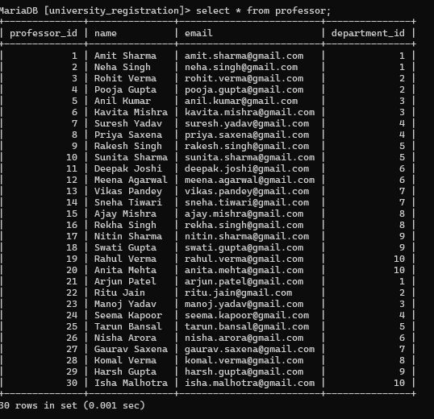

INSERT INTO course (course_name, credits, department_id, professor_id) VALUES ('Data Structures', 4, 1, 1) , ('Database Management', 4, 1, 2) , ('Operating Systems', 4, 1, 21) , ('Computer Networks', 3, 2, 3) , ('Web Development', 3, 2, 4) , ('Thermodynamics', 4, 3, 5) , ('Machine Design', 4, 3, 6) , ('Structural Analysis', 4, 4, 7) , ('Surveying', 3, 4, 8) , ('Electrical Circuits', 4, 5, 9) , ('Power Systems', 4, 5, 10) , ('Digital Electronics', 3, 6, 11) , ('Microprocessors', 3, 6, 12) , ('Linear Algebra', 4, 7, 13) , ('Calculus', 4, 7, 14) , ('Quantum Physics', 4, 8, 15) , ('Optics', 3, 8, 16) , ('Organic Chemistry', 4, 9, 17) , ('Physical Chemistry', 4, 9, 18) , ('Business Management', 3, 10, 19);

QUERY:
SELECT * FROM COURSE;
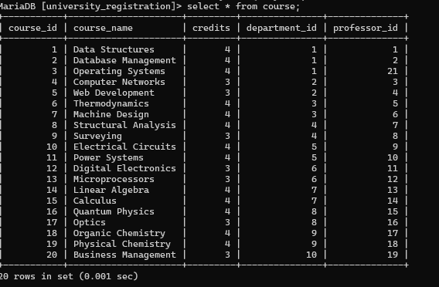

INSERT INTO student (name, email, phone, dob, parents_name, department_id) VALUES ('Rahul Sharma', 'rahul1@gmail.com', '9876543210', '2002-05-10', 'Ramesh Sharma', 1) , ('Ankit Verma', 'ankit2@gmail.com', '9876543211', '2001-08-15', 'Suresh Verma', 2) ,
('Priya Singh', 'priya3@gmail.com', '9876543212', '2002-03-20', 'Mahesh Singh', 1),
('Neha Gupta', 'neha4@gmail.com', '9876543213', '2001-11-25', 'Rajesh Gupta', 3),
('Amit Kumar', 'amit5@gmail.com', '9876543214', '2002-07-30', 'Shyam Kumar', 4),
('Pooja Sharma', 'pooja6@gmail.com', '9876543215', '2001-01-18', 'Ravi Sharma', 5),
('Rohit Yadav', 'rohit7@gmail.com', '9876543216', '2002-09-05', 'Mohan Yadav', 6),
('Sneha Verma', 'sneha8@gmail.com', '9876543217', '2001-12-12', 'Vikas Verma', 7),
('Karan Singh', 'karan9@gmail.com', '9876543218', '2002-04-22', 'Arjun Singh', 8),
('Simran Kaur', 'simran10@gmail.com', '9876543219', '2001-06-14', 'Harpreet Kaur', 9),
('Aditya Sharma', 'aditya11@gmail.com', '9876543220', '2002-02-11', 'Rakesh Sharma', 10),
('Nikita Jain', 'nikita12@gmail.com', '9876543221', '2001-10-09', 'Sanjay Jain', 1),
('Vivek Mishra', 'vivek13@gmail.com', '9876543222', '2002-08-19', 'Dinesh Mishra', 2),
('Swati Singh', 'swati14@gmail.com', '9876543223', '2001-05-27', 'Alok Singh', 3),
('Deepak Gupta', 'deepak15@gmail.com', '9876543224', '2002-12-01', 'Prakash Gupta', 4),
('Riya Sharma', 'riya16@gmail.com', '9876543225', '2001-03-03', 'Sunil Sharma', 5),
('Manish Yadav', 'manish17@gmail.com', '9876543226', '2002-07-17', 'Raj Yadav', 6),
('Anjali Verma', 'anjali18@gmail.com', '9876543227', '2001-09-29', 'Kamal Verma', 7),
('Saurabh Singh', 'saurabh19@gmail.com', '9876543228', '2002-11-11', 'Gopal Singh', 8),
('Megha Gupta', 'megha20@gmail.com', '9876543229', '2001-02-06', 'Anil Gupta', 9);

QUERY: SELECT * FROM STUDENT;
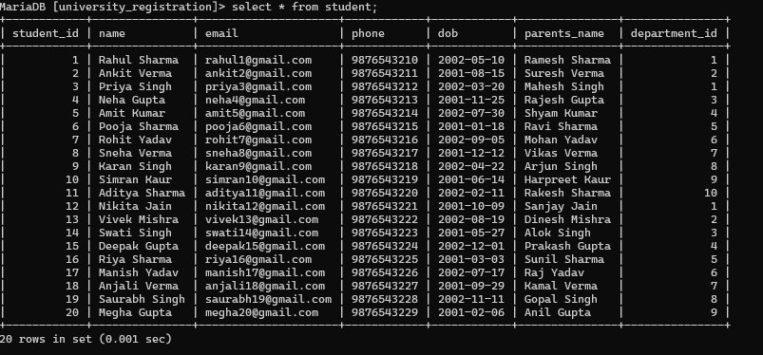
INSERT INTO enrollment (student_id, course_id, enrollment_date, grade) VALUES (1,1,'2024-01-10','A') , (2,2,'2024-01-11','B') , (3,3,'2024-01-12','A') , (4,4,'2024-01-13','C') , (5,5,'2024-01-14','B') , (6,6,'2024-01-15','A') , (7,7,'2024-01-16','B') , (8,8,'2024-01-17','A') , (9,9,'2024-01-18','C') , (10,10,'2024-01-19','B') ;
QUERY: SELECT * FROM ENROLLMENT;
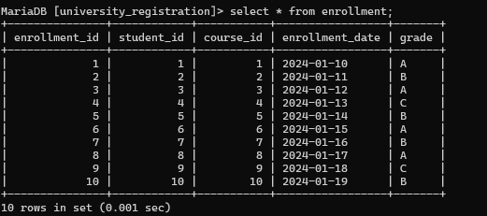

1. Show student names and phone numbers
Relational Algebra:
π(name, phone) (Student)
SQL: SELECT name, phone FROM student;
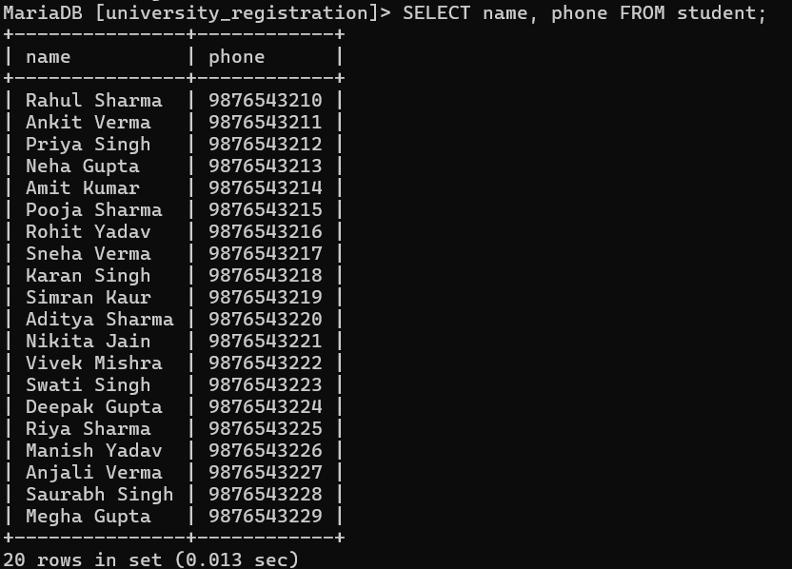
2. Show course names and credits
Relational Algebra:
π(course_name, credits) (Course)
SQL: SELECT course_name, credits FROM course;
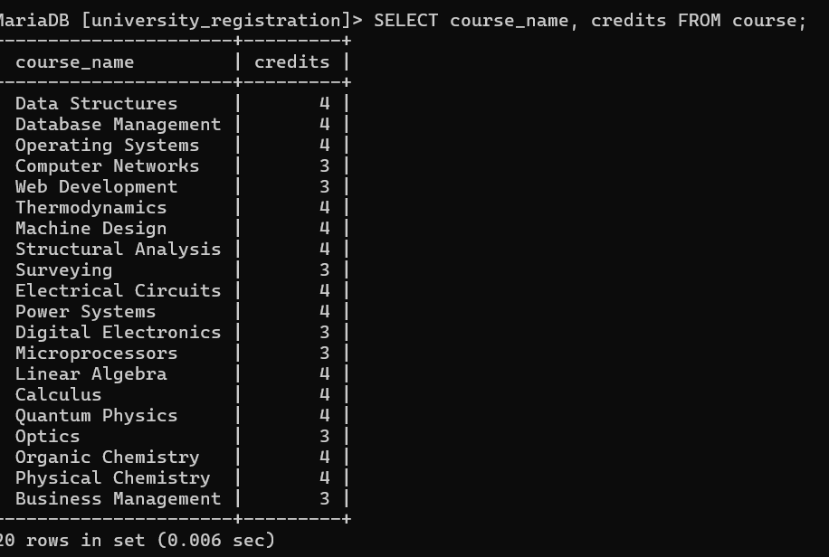
3. Show department names only
Relational Algebra:
π(department_name) (Department)
SQL: SELECT department_name FROM department;
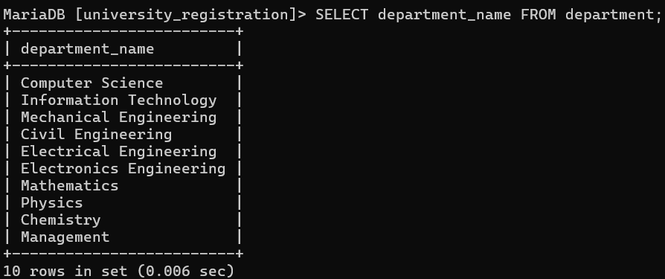
4. Show professors from department 1
Relational Algebra:
σ(department_id = 1) (Professor)
SQL: SELECT * FROM professor WHERE department_id = 1;
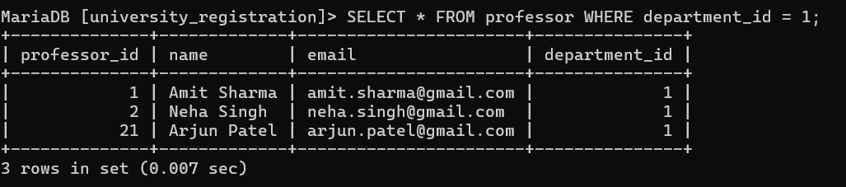
5. Show students born after 2002
Relational Algebra:
σ(dob > '2002-01-01') (Student)
SQL: SELECT * FROM student WHERE dob > '2002-01-01';
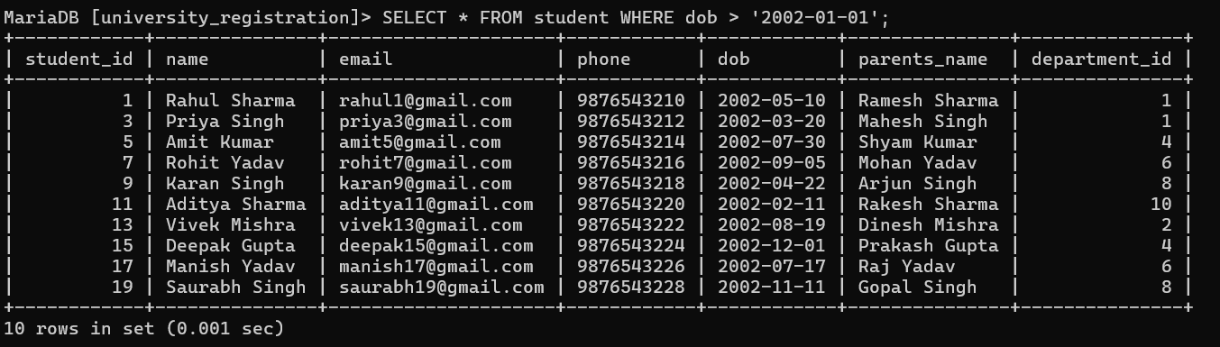
6. Show courses with 3 credits
Relational Algebra:
σ(credits = 3) (Course)
SQL: SELECT * FROM course WHERE credits = 3;
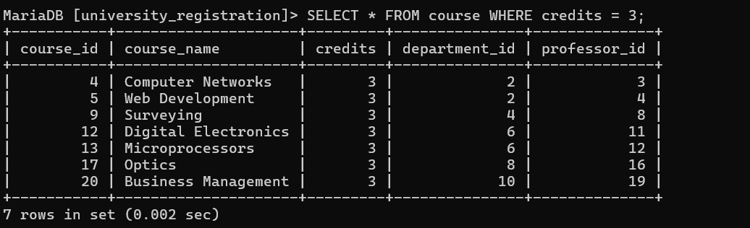
7. Show enrollment dates only
Relational Algebra:
π(enrollment_date) (Enrollment)
SQL: SELECT enrollment_date FROM enrollment;
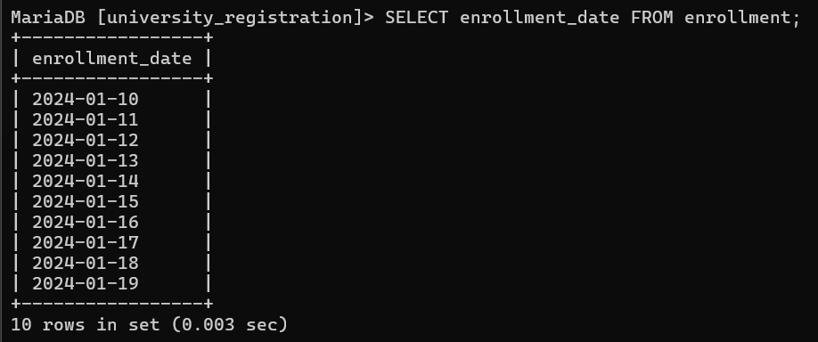
8. Show student names and their department IDs
Relational Algebra:
π(name, department_id) (Student)
SQL: SELECT name, department_id FROM student;
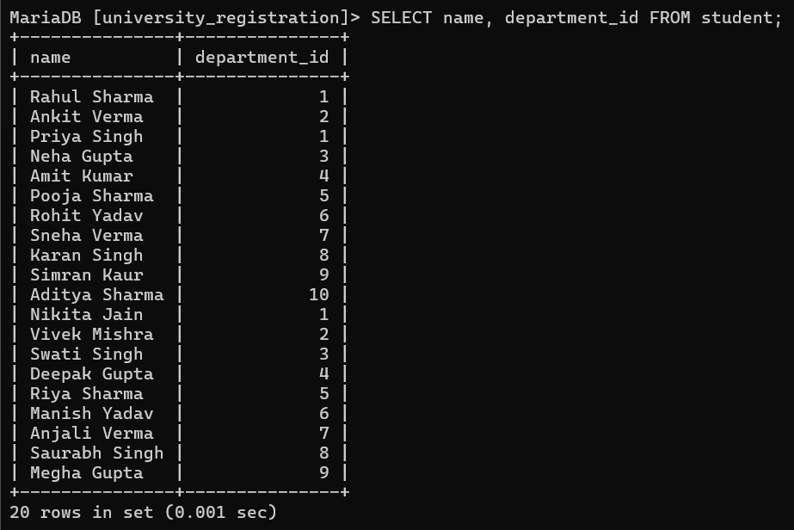
9. Show professor emails
Relational Algebra:
π(email) (Professor)
SQL: SELECT email FROM professor;
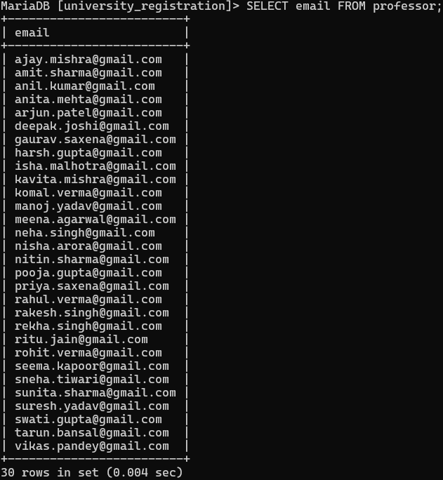
10. Show grades from enrollment
Relational Algebra:
π(grade) (Enrollment)
SQL: SELECT grade FROM enrollment;
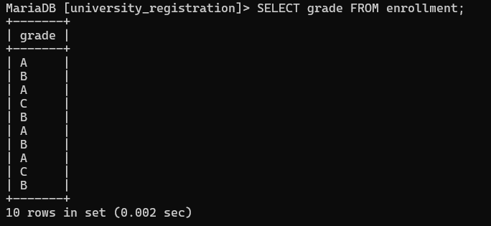

PHASE 3: DATABASE NORMALIZATION
we perform normalization on all five database tables of the University Course Registration System and apply the appropriate Normal Forms (1NF, 2NF, and 3NF).

1. First Normal Form (1NF)
Definition: A table is in 1NF if all attributes contain atomic (indivisible) values, each column has a unique name, and there are no repeating groups.
Rule Check: All columns must hold single, atomic values. No multi-valued attributes allowed.
Query: SHOW TABLES ; (verify all 5 tables exist)
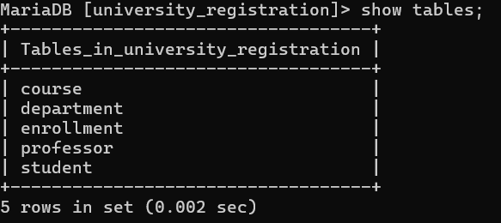
All 5 tables are present: course, department, enrollment, professor, student.
1NF Verification — DESC each table to confirm atomic columns:
Query: DESC department;
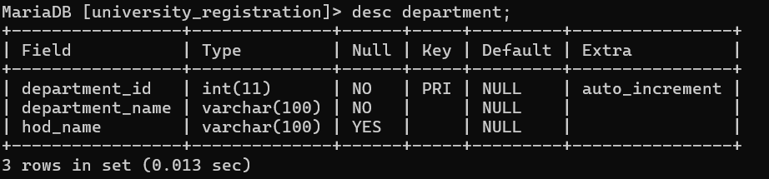
Result: department_id (PK, AUTO_INCREMENT), department_name (VARCHAR), hod_name (VARCHAR) — all atomic. 1NF: SATISFIED.
Query: DESC professor;
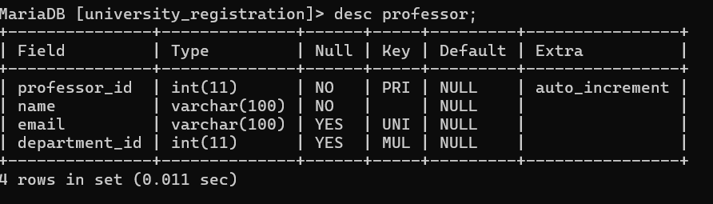
Result: professor_id (PK), name, email (UNI), department_id (MUL/FK) — all atomic. 1NF: SATISFIED.
Query: DESC student;
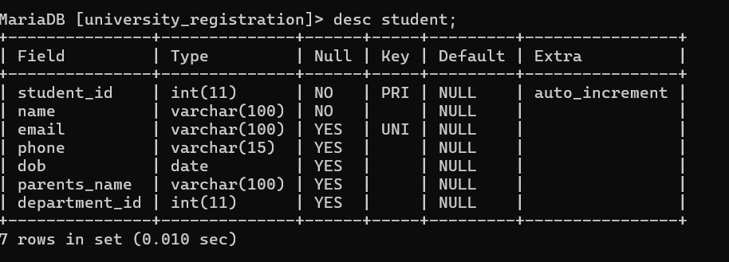
Result: student_id (PK), name, email (UNI), phone, dob, parents_name, department_id (FK) — all atomic. 1NF: SATISFIED.
Query: DESC course;
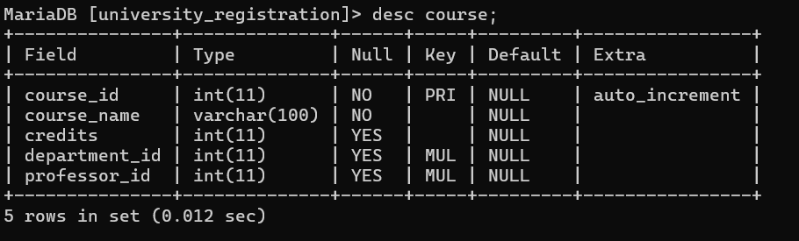
Result: course_id (PK), course_name, credits, department_id (FK), professor_id (FK) — all atomic. 1NF: SATISFIED.
Query: DESC enrollment;
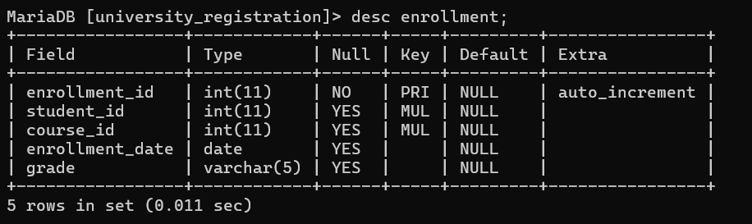
Result: enrollment_id (PK), student_id (FK), course_id (FK), enrollment_date, grade — all atomic. 1NF: SATISFIED.
Conclusion — 1NF: All five tables satisfy First Normal Form. Each attribute stores one atomic value per row. No repeating groups exist.

2. Second Normal Form (2NF)
Definition: A table is in 2NF if it is in 1NF AND every non-key attribute is fully functionally dependent on the entire primary key. Partial dependency (a non-key attribute depending on only part of a composite key) must not exist.
Analysis: All five tables use single-column AUTO_INCREMENT primary keys. Since there is no composite primary key in any table, partial dependency cannot occur by definition.
Query: SELECT department_id, department_name, hod_name FROM department;
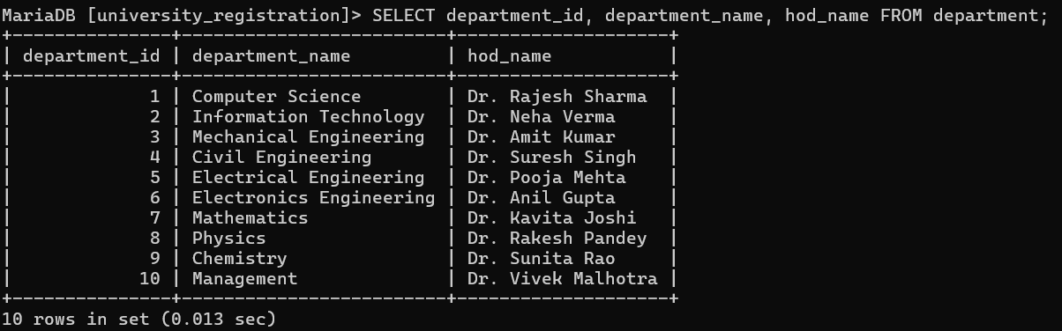
department_name and hod_name both depend fully on department_id (PK). No partial dependency. 2NF: SATISFIED.
Query: SELECT professor_id, name, email, department_id FROM professor LIMIT 5;
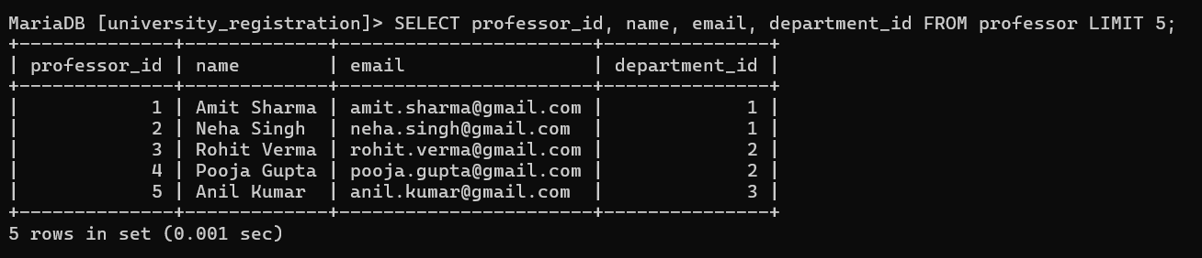
name, email, department_id all depend fully on professor_id (PK). No partial dependency. 2NF: SATISFIED.
Query: SELECT student_id, name, email, phone, dob, parents_name, department_id FROM student LIMIT 5;
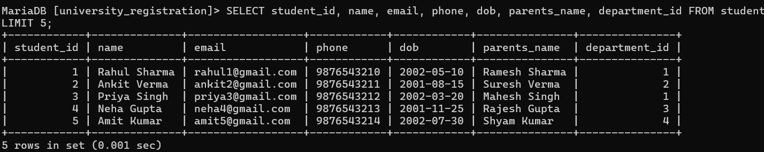
All attributes depend fully on student_id (PK). No partial dependency. 2NF: SATISFIED.
Query: SELECT course_id, course_name, credits, department_id, professor_id FROM course LIMIT 5;
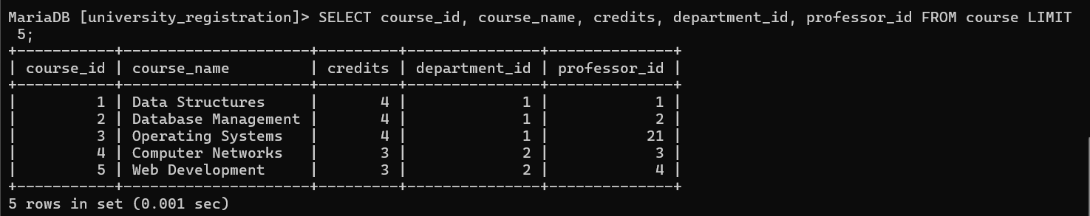
All attributes depend fully on course_id (PK). No partial dependency. 2NF: SATISFIED.
Query: SELECT enrollment_id, student_id, course_id, enrollment_date, grade FROM enrollment;
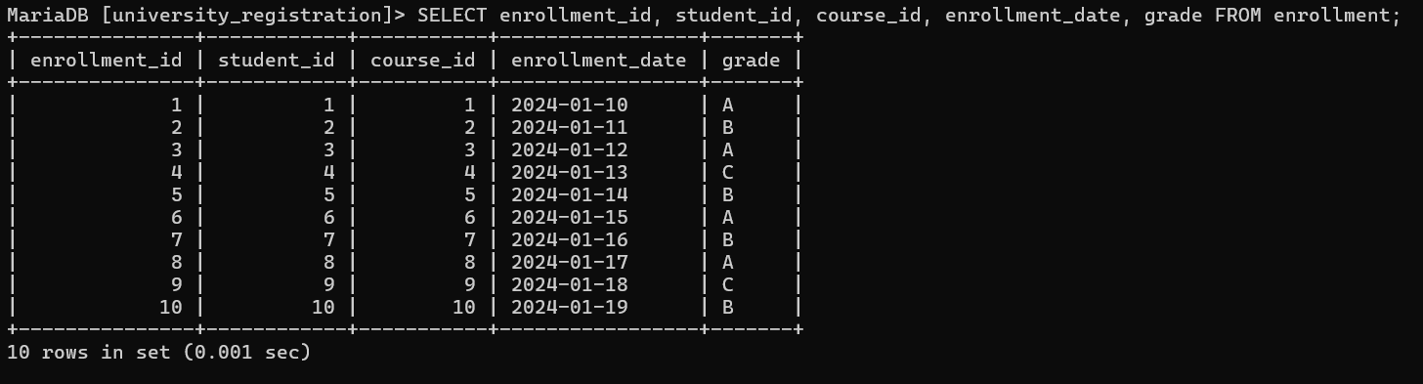
enrollment_date and grade depend on enrollment_id (PK). No partial dependency. 2NF: SATISFIED.
Conclusion — 2NF: All five tables satisfy Second Normal Form. No partial dependencies exist anywhere in the database.

3. Third Normal Form (3NF)
Definition: A table is in 3NF if it is in 2NF AND no non-key attribute is transitively dependent on the primary key through another non-key attribute (i.e., non-key attribute must NOT determine another non-key attribute).
Functional Dependencies in each table:
Department: department_id --> department_name, hod_name

department_id --> department_name

department_id --> hod_name
No non-key attribute determines another. 3NF: SATISFIED.
Professor: professor_id --> name, email, department_id

professor_id --> name

professor_id --> email

professor_id --> department_id (FK reference, not a transitive chain)
No transitive dependency. 3NF: SATISFIED.
Student: student_id --> name, email, phone, dob, parents_name, department_id

student_id --> name, email, phone, dob, parents_name, department_id
Each attribute is an independent fact about the student. No transitive dependency. 3NF: SATISFIED.
Course: course_id --> course_name, credits, department_id, professor_id

course_id --> course_name, credits, department_id, professor_id
Both department_id and professor_id are FK references stored as direct properties of the course. No transitive dependency. 3NF: SATISFIED.
Enrollment: enrollment_id --> student_id, course_id, enrollment_date, grade

enrollment_id --> student_id, course_id, enrollment_date, grade
grade depends on the enrollment event (enrollment_id), not transitively through student or course. 3NF: SATISFIED.
SQL Verification — Check all Primary Keys and Foreign Keys across all tables:
Query: SELECT TABLE_NAME, COLUMN_NAME, COLUMN_KEY FROM information_schema.COLUMNS WHERE TABLE_SCHEMA='university_registration';
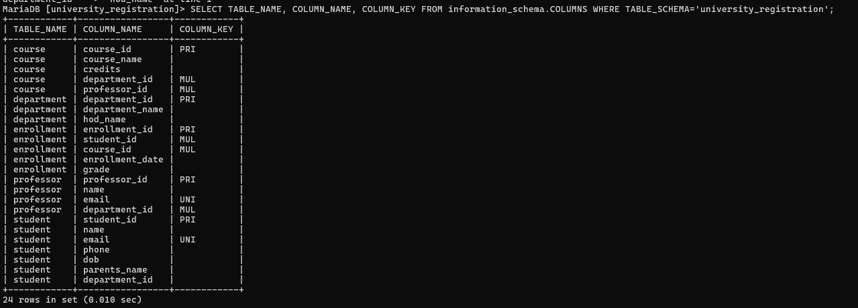
All PRI (primary key) columns are auto-increment integers. All MUL (foreign key) columns are direct references. No non-key column determines another non-key column. Database is in 3NF.
Conclusion — 3NF: All five tables satisfy Third Normal Form. No transitive dependencies exist. Every non-key attribute depends directly and only on the primary key.

4. Normalization Summary
The University Course Registration System database has been analyzed for all three Normal Forms:
Department Table : 1NF - YES | 2NF - YES | 3NF - YES
Professor Table : 1NF - YES | 2NF - YES | 3NF - YES
Student Table : 1NF - YES | 2NF - YES | 3NF - YES
Course Table : 1NF - YES | 2NF - YES | 3NF - YES
Enrollment Table : 1NF - YES | 2NF - YES | 3NF - YES
Final Result: The University Course Registration System database is fully normalized up to Third Normal Form (3NF). The schema is free from data redundancy, partial dependencies, and transitive dependencies. No decomposition of any table was required as the design was inherently normalized during Phase 1.

